|  |
| --- |
| SHADOW sOFTWORKS |
| Platformer |
| Assignment 1 2D Platformer |
| Version 1.0  All work Copyright © 2015 by Shadow Softworks Games.  All rights reserved. |
| **Seth Kaminski** |
|  |



|  |
| --- |
| Oct 5th 2015 |

**Table of Contents**

Title page-------------------------------------------------------------------------------------------------------------pg1

Table of Contents --------------------------------------------------------------------------------------------------pg2

Version History------------------------------------------------------------------------------------------------------pg3

Game Overview ----------------------------------------------------------------------------------------------------pg4

Controls---------------------------------------------------------------------------------------------------------------pg4

Interface Sketch----------------------------------------------------------------------------------------------------pg4

Screen Descriptions------------------------------------------------------------------------------------------------pg5

Characters------------------------------------------------------------------------------------------------------------pg5

Enemies---------------------------------------------------------------------------------------------------------------pg5

Scoring----------------------------------------------------------------------------------------------------------------pg5

Sound Index----------------------------------------------------------------------------------------------------------pg5

Art / Multimedia Index--------------------------------------------------------------------------------------------pg5

**Version History**

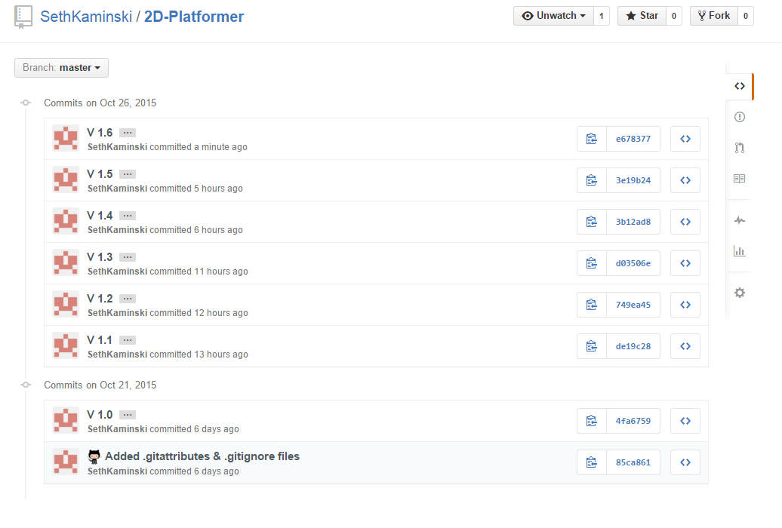

1. **Game Overview**

*You are an astronaut and need to get to the other side of the world.*

1. **Controls**

*A to move left and D to move the player right. Space to jump.*

1. **Interface Sketch**

*Red = enemies*

*Orange = player*

*Green = Patform*

1. **Screen Descriptions**

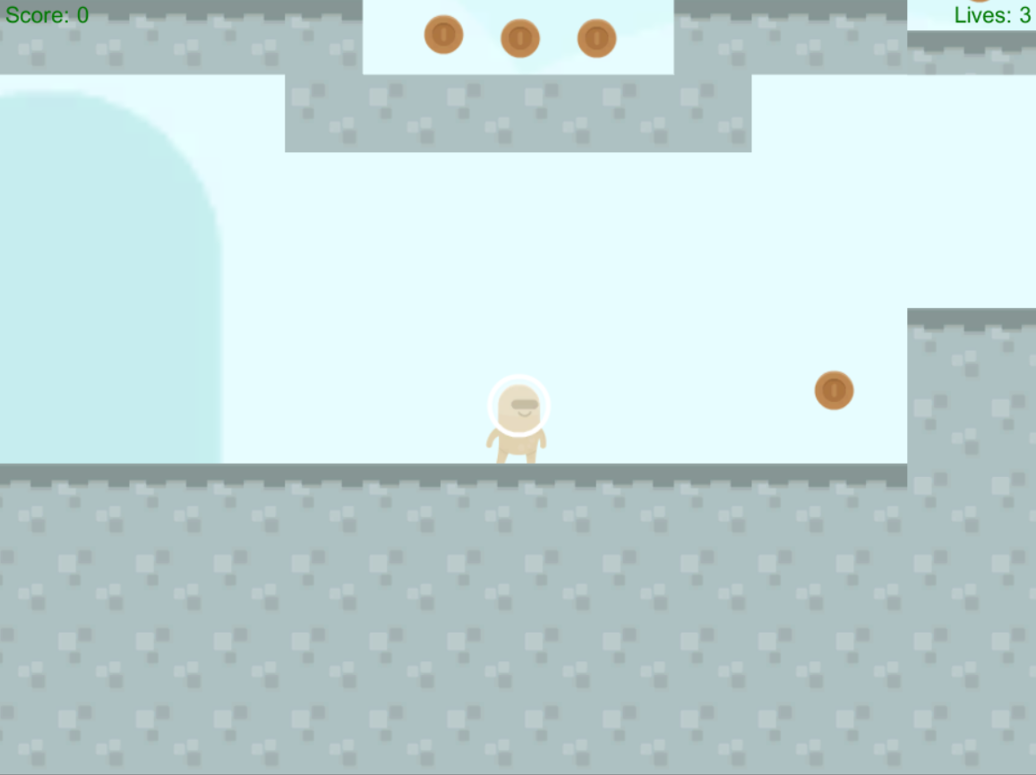 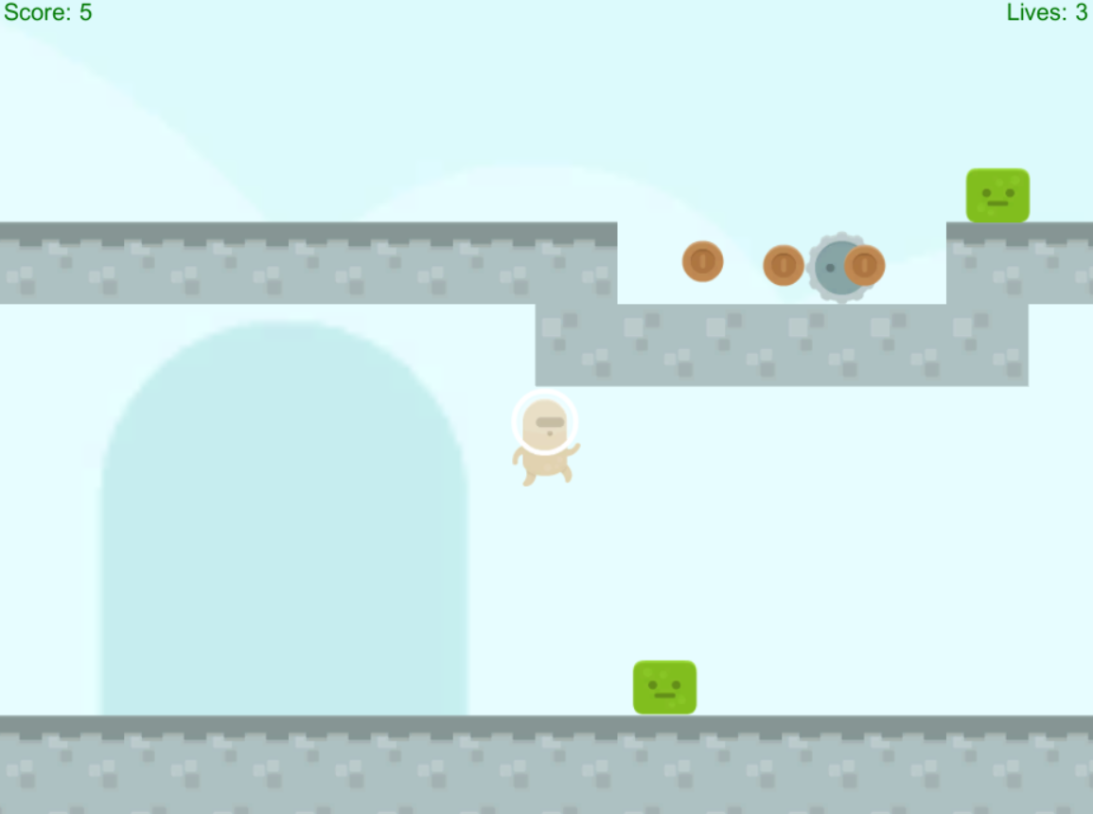**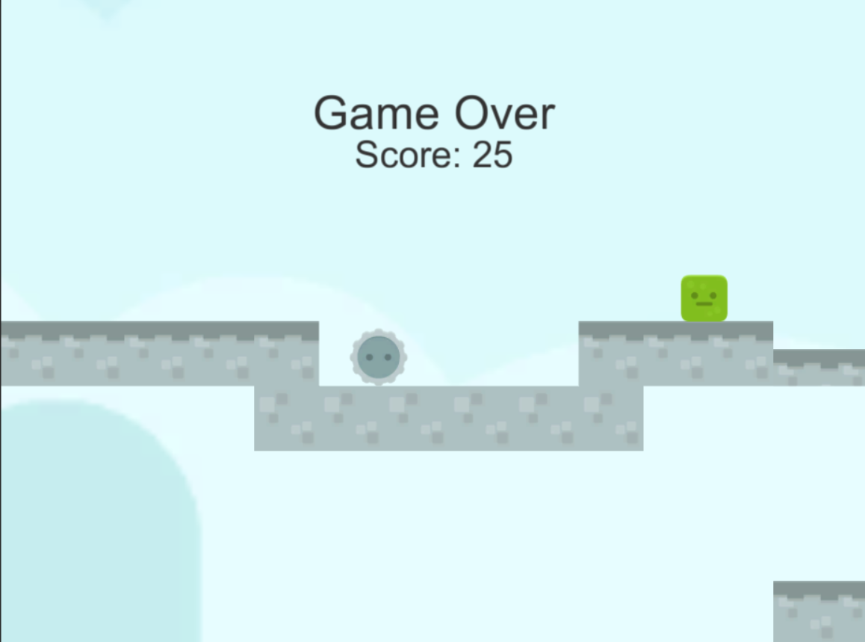

1. **Characters**

*You are brown astronaut.*

1. **Enemies**

*Saw: fall off platforms and bounds off walls.*

*Slime Cube: does so fall off platforms but still bounds off walls.*

1. **Scoring**

5 point pre copper coin.

1. **Sound Index**

*Most sound from Kenney of OpenGameArt.org*

[*http://opengameart.org/content/space-shooter-redux*](http://opengameart.org/content/space-shooter-redux)

1. **Art / Multimedia Index**

*All art coms from Kenney of OpenGameArt.org*

<http://opengameart.org/content/platformer-pack-redux-360-assets>